

Things I’m good at

* I have
* I can

**Things about me**

* I am

**How I communicate**

* I use
* I do
* I speak with



Tricky things

* I don’t like
* It’s difficult for me
* I need you to help me
* I’m still working on

**My favourite things**

* I like

Things that help me

* It helps me if you



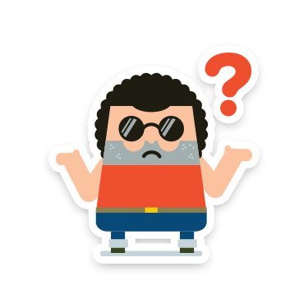

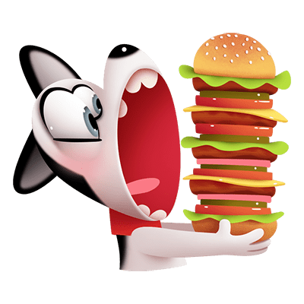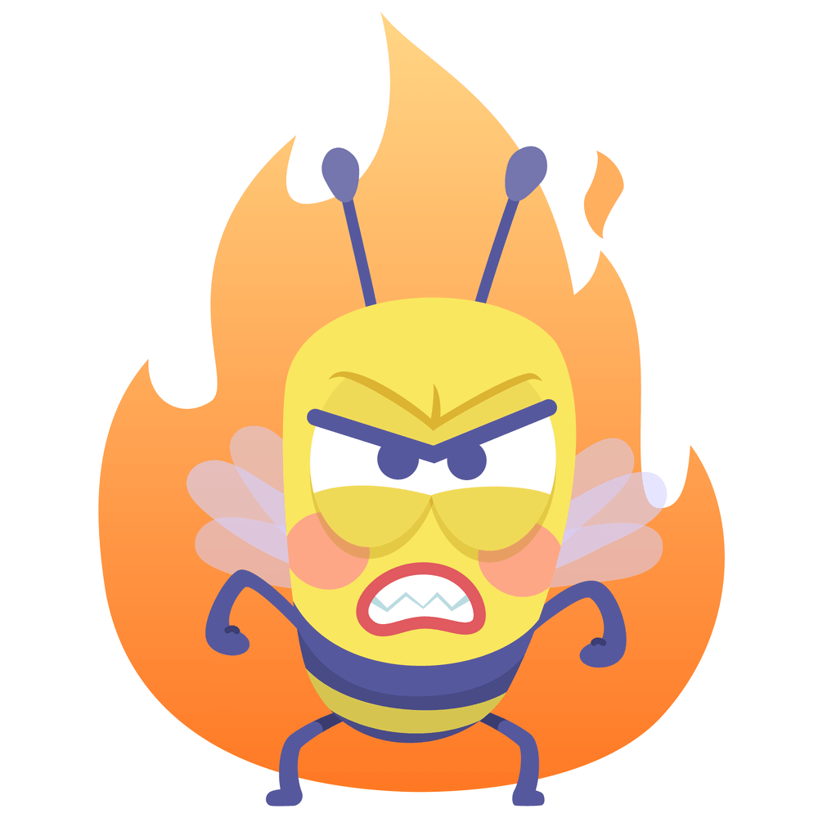





Replace with photo

**More things you need to know about me**

**Important people**

If you want to find out more about Passports, look up [www.communicationpassports.org.uk](http://www.communicationpassports.org.uk)

If you want to find out more about Passports, look up www.communicationpassports. org.uk

Hi, I’m

X

* I’m x years old
* I live in x
* I have one big brother
* I have two sisters, X and A
* I have an X cat dog called X
* I go to X school
* I’m in PX

